KOREAN DRAMA

**TEAM NAME: WHOLE STORY**

**TEAM LEADER**: Madhavika.P

**TEAM MEMBERS**: Sathiya.M , Tamarai selvi.A , Jaisree.R.G

**HTML WEBSITE:**

<html>

<head>

<title>Analysis</title>

</head>

<body>

<iframe src="https://us1.ca.analytics.ibm.com/bi/?perspective=story&amp;pathRef=.my_folders%2Fstory%2Bboard&amp;closeWindowOnLastView=true&amp;ui_appbar=false&amp;ui_navbar=false&amp;shareMode=embedded&amp;action=view&amp;sceneId=-2&amp;sceneTime=0" width="1320" height="1200" frameborder="0" gesture="media" allow="encrypted-media" allowfullscreen=""></iframe>

<iframe src="https://us1.ca.analytics.ibm.com/bi/?perspective=dashboard&amp;pathRef=.my_folders%2Fkdrama%2Bdashboard&amp;closeWindowOnLastView=true&amp;ui_appbar=false&amp;ui_navbar=false&amp;shareMode=embedded&amp;action=view&amp;mode=dashboard&amp;subView=model0000018a26ee89a8_00000006" width="1320" height="1200" frameborder="0" gesture="media" allow="encrypted-media" allowfullscreen=""></iframe>

<iframe src="https://us1.ca.analytics.ibm.com/bi/?perspective=explore&amp;pathRef=.my_folders%2FNew%2Bexploration%2Bkd&amp;closeWindowOnLastView=true&amp;ui_appbar=false&amp;ui_navbar=false&amp;shareMode=embedded&amp;subView=model0000018a2b28b41d_00000003" width="1320" height="1200" frameborder="0" gesture="media" allow="encrypted-media" allowfullscreen=""></iframe>

</body>

</html>

**OUTPUT:**

**DASHBOARD:**

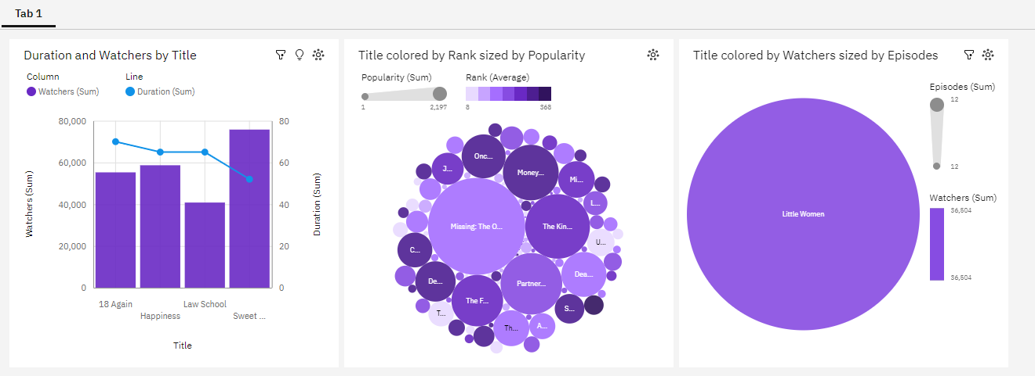

**EXPLORATION:**

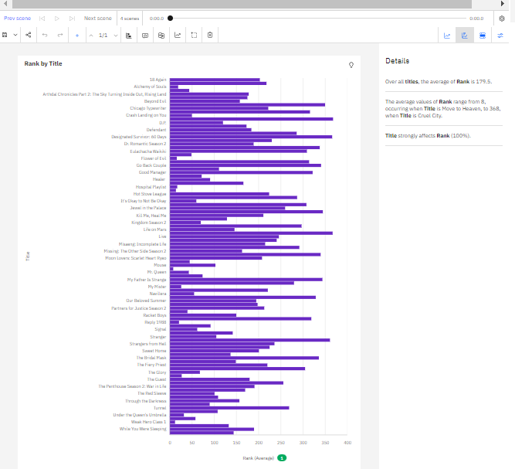

**STORY BOARD:**

